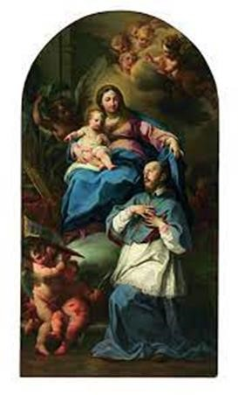
RETURN TO THE WAY 0F THE HEART
Dear friends of ADMA,
First of all, we wish everyone a peaceful 2022. We entrust this new year to the Help of Christians, in the hope that she will help us to live it always in the light and joy that the birth of Jesus has brought to our hearts. We have just ended the season of Christmas. God has become man and manifested himself to the world. This proclamation has changed the history of humanity forever and above all it changes our humanity today: it asks us to be converted every day and to be witnesses every day of the Gospel, glorifying the Lord at all times and in every circumstance!
How do we do this? What attitudes do we need? January is a very special month for the whole Salesian Family, first of all because we receive the Rector Major's Strenna as a gift which guides our journey, and then because we celebrate some Salesian feasts and so rediscover and revive our sense of being children of Don Bosco and of the Help of Christians - on 24 January the feast of Saint Francis de Sales whose 400th anniversary we celebrate, and then on 31 January the feast of our father Saint John Bosco. The beautiful Strenna of the Rector Major "Do everything out of love, nothing by constraint" shows us how and offers us the right attitudes. The Strenna focuses on the spirituality of St. Francis de Sales, which is the "source of the spirit of Don Bosco". It invites all of us in the Salesian Family to commit ourselves to an essential element of our charism which is to take up the path of the heart - a simple, sweet, patient, devoted heart. A heart with a deep desire for God created by God who leaves us free to correspond to his loving plan. For us in ADMA it is once again a question of following in Mary's footsteps and looking at her heart. Learn from Mary to do everything for love of God and neighbour without constraint and rediscover the sense of true devotion as taught by St. Francis de Sales: "True and living devotion, Philothea, requires the love of God, indeed it is nothing other than a true love of God, not love in a generic sense. God's love is called grace insofar as it embellishes the soul, because it makes us acceptable to the divine Majesty. It is called charity inasmuch as it gives us the strength to act well. When it has reached such a level of perfection, whereby it not only gives us the strength to act well, but makes us work carefully, often and promptly, then it is called devotion [...]. To put it briefly, devotion is a kind of spiritual agility and liveliness by which charity acts in us or we act through it, with promptness and affection."
The hope then is that in all the educational and pastoral activities in which we are involved, in our formation meetings, and in the works in which we are engaged, our devotion as ADMA members will help us to love our neighbour more and abandon ourselves more to the love of God.
Renato Valera, President ADMA Valdocco.
Alejandro Guevara, Spiritual Animator ADMA Valdocco.

Formation Programme 2020-2021

Family love, vocation and a life of holiness
OUR DAILY LOVE (2)

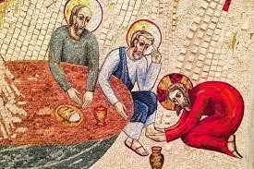
1. Married love and “Salesian love”.
All true love, be it married love, family love or educational love, is a sign of God's love.
The Pope says: "Marriage is the image of God's love for us. The spouses, by virtue of the sacrament, are invested with an authentic mission, to make visible, starting from simple and ordinary things, the 'love with which Christ loves her Church, He continues to give his life for her ... Married love is capable of surviving even when feelings and passion are weakened.
The "Salesian affection" of the Preventive System also has as its source and root the deep supernatural love of the Good Shepherd. The Identity Card of the Salesian Family reminds us: it is a love which demands a strong spiritual effort: self-renunciation and sacrifice, chastity in affections and self-control in attitudes … endless hope. There is no real love without asceticism and there is no asceticism without an encounter with God in prayer. Salesian loving kindness is the fruit of pastoral charity. “It is based on the desire I have to save your souls,” Don Bosco used to say.
In this way loving kindness becomes a sign of the love of God, and a way of evangelization. The apostolic spirituality of the Salesian Family is characterised, not by love understood in a generic sense, but by the ability to love and be loved. (Identity Card of the Salesian Family, art.32)
Pascual Chávez describes it in the Strenna for 2013: "This love is enriched by the human value of reason and intelligence which keeps us from falling into sentimentality. This provides the inner balance to keep us from falling into rigid, authoritarian, paternalistic positions. It consists of a profound empathy, capacity for dialogue, cordiality, and understanding. This translates into the commitment to be a person "consecrated" to the good of others, of young people, ready to accept difficulties and sacrifices."
2. How do we grow in married love, how can we live "our whole lives, with everything in common"?
- Married love is the "highest friendship", says Pope Francis, because it is a search for the good of the other person, and requires reciprocity, intimacy, tenderness, and stability.
- It has an indissoluble exclusivity. One who is in love does not think that this relationship will last only for a while. Those who live the joy of marriage intensely do not think of something fleeting. They hope that it will last over time. Children want their parents not only to love each other, but also to be faithful and always stay together.
- The union that crystallizes in the promise to marry forever is more than a social formality or a tradition. For believers it is a covenant before God that demands fidelity. It presupposes the gift of grace which strengthens and elevates it.
- It is a love that fills life with joy and beauty, because it leads us to regard the other person as what is most precious, what is most important to me. Love opens our eyes and allows us to see, beyond the limits, what a human being is worth.
-The most intense joys in life come when we bring happiness to others in an anticipation of heaven.
-This joy is renewed when two people love each other and achieve together something that has cost them a great common effort. Joy is renewed in the pain overcome together.
- Love needs to be manifested ... and to grow continuously. How? In the family "three words are necessary. They are please, thank you, and sorry - three key words!" When you are not demanding and ask for "permission", when you are not selfish and learn to say, "thank you", and when you realize that you have done something wrong and know how to ask for "forgiveness", in that family there is peace and joy." - Pope Francis
- Love grows through dialogue. Often one of the spouses does not need a solution to his or her problems but needs to be heard .... For a married couple many arguments are not about very serious matters. Sometimes they are small, unimportant things, but what disturbs the atmosphere is the way things are said or the attitude adopted.

3.- Relying on feelings can bring us only so far
- To think we are good just because we "feel things" is a tremendous illusion if it conceals a hidden self-centredness without any great values. But feeling an emotion, starting to feel desire or rejection is neither sinful nor reprehensible. Jesus, as a real man, also had human emotions. When he saw others cry, he was moved and troubled (cf. Jn 11:33).
- The Church is not the enemy of human happiness. It does not disapprove of moments of intense joy, intertwined with other moments of generous dedication and struggling for an ideal.
- God created sexuality which is a wonderful gift. It is an interpersonal relationship where the other person is taken seriously, with their sacred and inviolable value, and is not just a resource to gratify or entertain oneself. It is the gift of God that embellishes the marriage encounter.
- Sexuality is sometimes depersonalized and full of pathologies, possessed by a throw-away poison. A marital act imposed on a spouse without considering their current situation and legitimate desires is not a true act of love. Nor can the human person live exclusively on a love of giving. One must not only give but also receive. Whoever wants to give love must in turn receive it as a gift. Virginity is another form of love. It is an "eschatological" sign of the risen Christ, and marriage is a "historical" sign for us who walk the earth, a sign of the earthly Christ who gave himself to the point of giving us his blood.
4.- Married love needs a stable common project.
Physical appearance changes, but this is not a reason why the attraction of love weakens. We cannot promise to have the same feelings for the rest of our life. On the other hand, we can have a stable common project by committing ourselves to love and to live together until death do us part, and always share a rich intimacy.
But all this is not possible without invoking the Holy Spirit, without invoking God’s grace every day, to strengthen our love, to guide it and transform it in every new situation.

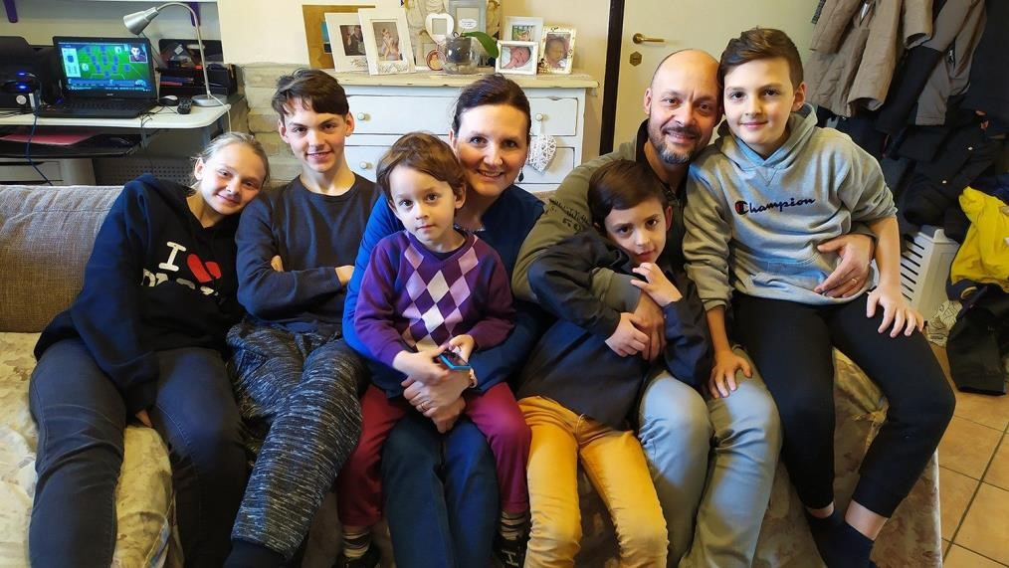
For dialogue:
* Do you know situations of marriage breakdown due to fragility or improvisation of a still very adolescent love or other causes?
* What values or attitudes of Jesus in the Gospel help you most on your way to the "joy of love"?

* What steps are you trying to take to improve dialogue between spouses and between parents and children?

* Do you think it is possible for a person to be happy without truly loving someone or something?

GETTING TO KNOW EACH OTHER

SALESIAN FAMILY SPIRITUALITY DAYS
Commentary of the Rector Major on the Strenna for 2022
“Do everything out of love, nothing by constraint.”
(St Francis de Sales)
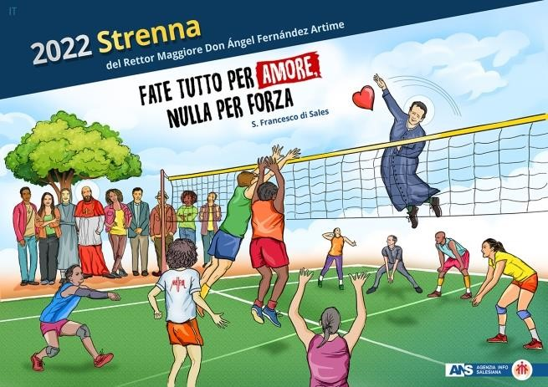
In this commentary on the 2022 Strenna for the Salesian Family I want to speak of two giants who are in continuity with one another in the Salesian charism, since both are a great gift in the Church and because Don Bosco, like no other, knew how to translate the spiritual strength of Francis de Sales into the day-by-day education and evangelisation of his poor boys. And, therefore, the entire Salesian Family continues to have this task in the Church and in today’s world.
From the outset I speak of two giants who are in continuity with one another in the Salesian charism, since both are a great gift in the Church and because Don Bosco, like no other, knew how to translate the spiritual strength of Francis de Sales into the day-by-day education and evangelisation of his poor boys. And, therefore, the entire Salesian Family continues to have this task in the Church and in today’s world.
This is why I would like to state from the outset that “symbolically”, both Francis de Sales and John Bosco (Don Bosco) have much in common from the cradle onwards.
Francis de Sales was born beneath the Savoyard sky that crowns the valleys crossed by streams rising from the highest peaks of the Alps.
How could we not think that John Bosco, too, was a “Savoyard”? He was not born in a castle but had the same gift as Francis did: a gentle, faith-filled mother. Françoise de Boisy was very young when she was pregnant with her first child, and at Annecy, before the Holy Shroud that spoke to her of the passion of God’s blessed Son, she was deeply moved and made a promise: this child would belong to Jesus forever.
One day Mamma Margaret would tell John: “When you came into the world, I consecrated you to the Blessed Virgin.”
Don Bosco, too, would kneel before the same Shroud in Turin. Christian mothers generate saints. In a castle, like Francis, or in a run-down country shack like John.
They say that the first sentence Francis managed to put together was: “The good God and my mother love me very much.”
The good God watched over Francis and John and gave them both a big heart. Francis studied in Paris and Padua, in the most famous universities in the world at the time. John studied by candlelight in an alcove in the “Caffè Pianta”. But the Spirit is not hindered by small human difficulties. The two were destined to somehow cross. And one day Don Bosco told a group of young men who had grown up with him: “We will call ourselves Salesians”. From that moment onwards, always led by the Spirit, the great tree of Don Bosco’s Family, the Salesian Family, began to grow.

St Francis de Sales is an historical figure who, with the passing of time, has grown in relevance and significance, thanks to the prolific dissemination of his insights, experiences and spiritual convictions. Four hundred years later, his proposal of Christian life, his method of spiritual accompaniment and his anthropological vision regarding the relationship between human beings and God are still fascinating.
The theme chosen for this Strenna for the Family, ever faithful to the legacy and tradition bequeathed to us by Don Bosco himself, comes from the pen of Francis de Sales who wrote to his spiritual daughter Jane Frances de Chantal “If you are greatly in love with the prayers you have mentioned, please do not change, but if you want to go against something I suggest, have no scruples, because the rule of our obedience, which I write in capital letters is: DO EVERYTHING OUT OF LOVE, NOTHING BY CONSTRAINT. IT IS BETTER TO LOVE OBEDIENCE THAN TO FEAR DISOBEDIENCE.”

What distinguishes our Salesian Family in today's manifold and different societies and cultures is precisely Don Bosco's Preventive System, which is capable of being applied, known and accepted in the most diverse contexts. I find many common elements in the article cited, and in the central lines of the thought and spirituality of St Francis de Sales, which allow me to initiate a dialogue between Francis de Sales and Don Bosco on the basis of what we discover here:

- Nothing through constraint. Freedom is God’s gift: → and it is because of this that our system of education appeals to other resources “instead of constraint”.
- God’s presence in the human heart: → through which we recognise the “love and the desire for God, which everyone has in the depths of his being”.
- Life in God: → which “brings together educators and youngsters [tr. note: the Italian text of the Constitutions includes here the phrase: “in un’unica esperienza di vita” which literally translates as “a unique experience of life”. This was omitted in the English text].
- A kind and friendly way of dealing with people: → which leads to living with our youngsters “in a family experience of trust and dialogue”.
- Unconditional and unrestrained love: → which makes it possible in our family that by “Imitating God's patience, we encounter the young at their present stage of freedom”.
- With the need for a spiritual guide: → hence “We then accompany them, so that they may develop solid convictions”.
- Ultimately doing “All through love”: → so that “they may gradually assume responsibility for the delicate process of their growth as human beings and as people of faith.”
Here is the link for the full text of the Rector Major’s commentary and the video of the Strenna: https://www.sdb.org/it/Rettor_Maggiore/Strenna/Strenna_2022

REGULATIONS OF THE ASSOCIATION OF MARY HELP OF CHRISTIANS FOR STUDY AND IMPLEMENTATION OF OUR IDENTITY
ARTICLE 6 - ORGANIZATION The second part of the Regulations of our Association begins with article 6, in which we talk specifically about the structure and organization. The organization is an instrument of service to people and must be aimed at promoting, supporting and ordering fraternal relations and the commitment of the members to the apostolate. It must be simple and flexible, adaptable to the specific situations of different countries. In keeping with the Salesian spirit, a few clear, simple and shared rules are enough to help give continuity and order the good that is done. With this spirit, while respecting the legal formulations, it is appropriate to pay attention to the experience in recognizing the path of individual groups, highlighting the richness and fruitfulness it expresses, and not applying a single formula to the various local situations. What gives rise to the journey with Jesus and Mary is a great desire: to give back the good received. And so, it turns out that joining the association "is not limited to participation in moments of association. It becomes a lifestyle to be lived in the family, at work, in ecclesial, social and friendly relations". The primacy is given to prayer and the sacraments, which support any activity and work of charity. Fidelity to Jesus in the Eucharist and to Mary Help of Christians always translates into witness, apostolate and service.
Andrea and Maria Adele Damiani

The page can be read at the following site:
www.admadonbosco.org
To communicate with us, use the following electronic address:

animatore.spirituale@admadonbosco.org

FAMILY CHRONICLE
https://www.infoans.org/sezioni/notizie/item/14491-italia-gsfs-2022-non-abbiate-pauradell-interiorita-perche-rende-i-ragazzi-piu-vicini-a-dio?fbclid=IwAR3UwczB3pnnvjvHo29s-s0ClIqrT1uJ9qgk6iKXN380TXV-42ckzEkrJA

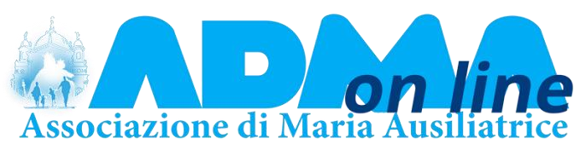
https://www.infoans.org/sezioni/l-approfondimento/item/14501-rmg-san-francesco-disales-ispiratore-di-cammini-di-santita?
fbclid=IwAR324bbxp6qtHxfHUTNd0NrThYwpdYoN_JgqqaNEKgZPgq3k62Zg79fKkA#.Yeet0KE-Ehc.facebook

https://donboscoitalia.it/italia-gsfs-2022-faremo-tutto-per-amore-nulla-per-forza/?
fbclid=IwAR275WqsIW62Vxb7LXNOaC9e_nVrxBJDZHF7xvcrrEmBsNh_LnlUsNlt YZY
